KENYA NATIONAL QUALIFICATIONS AUTHORITY

SHAPING THE FUTURE OF KENYA

Vision

Globally Recognized and Competitive Qualifications Transforming Kenya

Mission

To Establish and Manage the Kenya National Qualifications Framework, Register and Accredit qualifications, Recognize and Equate foreign qualifications and Create a Credit Accumulation and Transfer system to achieve global Recognition and Competitiveness.

Core values

Professionalism;
Integrity;
Teamwork;
Accountability; and
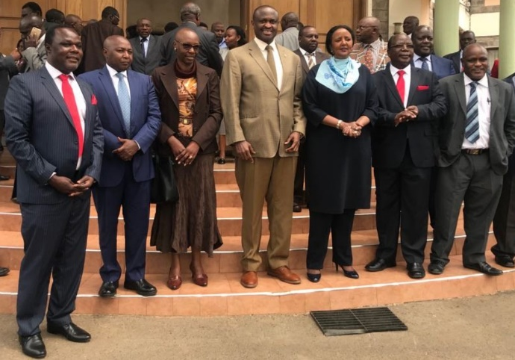
Responsiveness.
The Management of KNQA with CS Education Amb. Amina Mohamed

Who we Are
The Kenya National Qualifications Authority (KNQA) is an overall facilitator within the education sector in Kenya, cutting across the Basic, TVET and University sectors; assuring the quality of qualifications and accrediting, and registering Qualifications awarding Institutions (QAIs), Professional bodies, External Quality assurance agencies, as well as local and foreign assessment and examination bodies. The Authority also registers and accredits National qualifications and learners as set out in the Kenya National Qualifications Authority (KNQF) Act No. 22 of 2014; and KNQF Regulations, 2018.

“All Education and Training Institutions are required to liaise with the KNQA to place their qualifications on the NQF, in accordance with KNQA’s regulations, standards and guidelines”.

The Kenya National Qualifications Framework (KNQF)
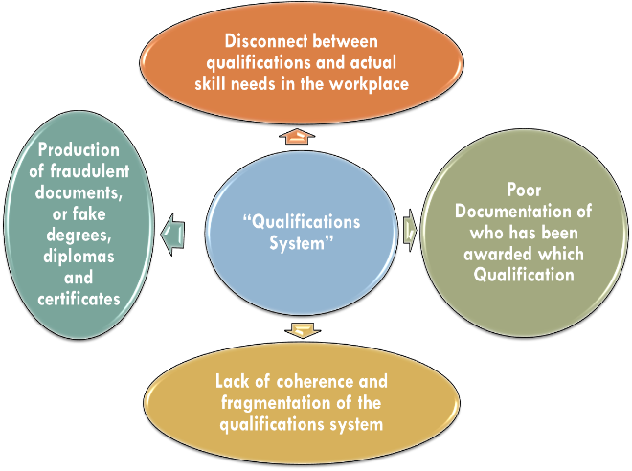
The KNQF is a learning outcome-based qualifications framework, comprising of all educational and training sectors and all forms of learning; formal, non-formal and informal learning. The KNQF comprises of levels, each being identified by a unique set of Level Descriptors. In order to place a qualification on any KNQF level, the learning outcomes (L.O) of each unit comprising a qualification and the overall qualification learning outcomes are mapped against these Level Descriptors. At each level, the Level Descriptors are classified into three separate strands (categories) covering Knowledge, Skills and Competencies.
The Current Confusion bedeviling the Education Sector in Kenya

The Need for KNQF
The principles for which the KNQF is established is to promote access to and equity in education, quality and relevance of qualifications, evidence-based competence, and flexibility of access to and affordability of education, training assessment and qualifications. The decision to develop the Kenya National Qualifications Framework was made after several challenges were found to be facing the education system in the Kenya. These include:-
The CEOs of TVETA, KNQA and CUE meeting Stakeholders. KNQF is a Collaborative effort of several National Institutions
- Globalization, technological change and transformation;
- Poor linkages between qualifications and the labour market;
- Lack of consistency in qualifications (even among institutions offering same level qualifications); Bottlenecks and Dead ends;
- Absence of a system for comparing qualifications to each other;
- Pathways of progression between qualifications was unclear and cumbersome;
- The Value of qualifications to employers and learners was not clear unclear;
- The Country had an education system that was not able to address its social-economic and technical challenges appropriately;

Solutions provided
The vision of the KNQA is for these challenges to be addressed through the development of a comprehensive National Qualifications Framework (NQF) that extends across all sectors of our education and training, irrespective of the nature and form of learning. The KNQF does this by: -
To Make KNQA Work there has to be allot of Consultations

- Providing a stronger basis for understanding, comparing and recognizing of national and foreign qualifications;
- Improving the understanding of employers, industry, parents and learners of the value of our qualifications;
- Providing fit-for-purpose qualifications that have stronger linkages with the labour market and learner needs;
- Increasing accountability of our education and training institutions towards maintaining high quality standards and relevance in their systems;
- Providing opportunities for mobility and progression of learners within and across higher education, vocational and general education sectors;
- Promoting the concept of lifelong learning through the recognition of all types of learning (formal, non-formal and informal);

What does the KNQA do?
- Listing Qualifications Awarding institutions (QAIs), Professional Bodies, Local and foreign Assessment and Examination bodies and External quality Assurance agencies (ETQAs) in the KNQF Register;
- Registering qualifications in the KNQF (thereby providing National and
International exposure of the Programs);
- Ensuring that descriptors of qualifications comply with KNQF requirements (level descriptors; Competency based; and are described using learning outcomes);
- Establishing and maintaining the KNQF and a National Learner Records Database (NLRD);
- Promoting lifelong learning and Recognizing Prior Learning (RPL);
- Aligning foreign qualifications with local Qualifications; (comparability);
- Promoting a system of Credit Accumulation and Transfer (CATs) that works for all levels of our education system (vertically and horizontally);
- Recognizing and Equating foreign Qualifications (REQs);
- Providing Regional and International exposure to local qualifications;
- Researching and documenting best practices in the management of National Qualifications;
- Coordinating and harmonizing our education system for efficiency, inclusivity, harmony and quality;

How to participate
- The Institution and Qualifications needs to be accredited by a recognized Quality Assurance and/or Professional Body (such as TVETA or CUE or any other ETQAs in the country of origin of the Qualification);
- The learner must have qualified to be admitted into the Qualification and took the right volume of learning to qualify for the award of the Qualification;
- Your qualifications need to comply with KNQF requirements (competence based; and described using learning outcomes);
- Meets all the other requirements for accreditation of institutions, qualifications and learners as set out in the KNQF regulations, 2018.

Contact us
For enquiries or to register your organization or qualification(s) into the KNQF visit or write to us;

The Director General
Kenya National Qualifications Authority (KNQA)
Uchumi House 6th floor, Aga Khan Walk
P.O. Box 72635-00200
Phone: +254-721624977
Email: knqa.go.ke@gmail.com
Website: www.Knqa.go.ke

