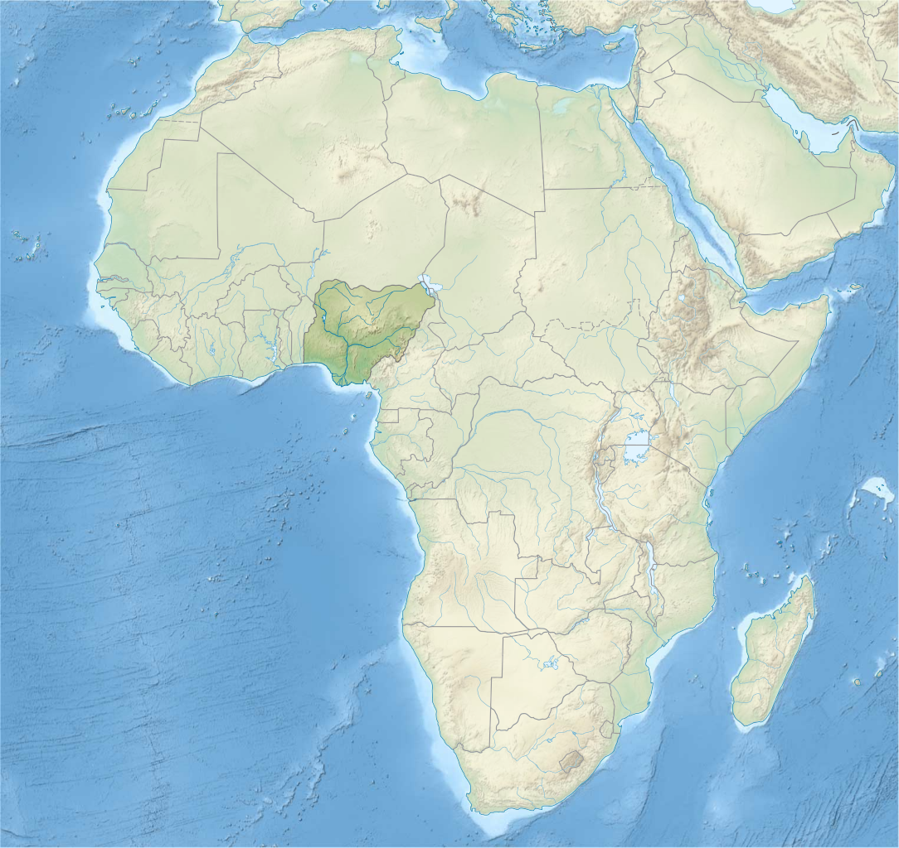

AFRICAN CONTINENTAL QUALIFICATIONS FRAMEWORK
KENYA NATIONAL QUALIFICATIONS AUTHORITY
Email: knqa.go.ke@gmail.com
Website: http://www.knqa.go.ke/

A MAPPING STUDY TO FORMULATE THE AFRICAN CONTINENTAL QUALIFICATIONS FRAMEWORK (ACQF) KICKS OFF
The First Ten-year Implementation Plan of the Africa Agenda 2063 foresees that the African Continental Educational Qualification Framework is developed and a common educational qualification system for Africa is in place by 2023. This is aimed at promoting free movement of persons, free trade but also a common education space for all African learners through recognition and harmonization of qualifications. The African Continental Free Trade Area (AfCFTA) is a key flagship of African integration wherein the ACQF will contribute. Thus the need for formulation of the ACQF between 2019-2022.
Skills and qualifications of the people in Africa are at the heart of African renaissance. Notably, Integrated Africa is a major transformational outcome of the Africa Agenda 2063.
The ACQF is hoped to:
- Enhance comparability, quality and transparency of qualifications from all sub-sectors and levels of education and training and support people’s lifelong learning outcomes;
- Facilitate recognition of diplomas and certificates;
- Work in complementarity with national and regional qualifications frameworks, and support the creation of a common African education space;
- Promote cooperation and alignment between qualifications framework (national, regional) in Africa and worldwide.

Based on the above, the African Union Commission (AUC) is partnering with EU, the Deutsche Gesellschaft für Internationaler Zusammenarbeit (GIZ) and the European Training Foundation (ETF) in spearheading development of the ACQF over the period 2019-2022. The ACQF Mapping Study is underway, and a consultative meeting with key stakeholders drawn from Kenya, IGAD, EAC, IUCEA will take place on 22nd January, 2020 at the United Kenya Club Nairobi.
The Kenya National Qualification Authority is co-hosting this meeting and will share its experiences to inform formulation and implementation of an ACQF. The meeting brings together 200 people from Kenya, the East African Community, IGAD, universities, policy makers, the TVET sector, the private sector and industries. The end result will be an African Continental Qualifications framework that will facilitate comparability of skills across various countries in the continent to support intra-Africa trade, and free movement of people, skills, goods and services as envisaged in the Africa vision 2063.
Dr. Eusebius J. Mukhwana
Director General
Kenya National Qualifications Authority (KNQA)
Po Box 72635-00200
Nairobi, Kenya
Tel: +254-20 2100272
Mobile: +254-721-624977
Email: knqa.go.ke@gmail.com

