Recognition of Prior Learning (RPL)
FAQs

Frequently Asked Questions (FAQ’s)
    - What Is Kenya National Qualifications Framework (KNQF)?
Kenya needs to create a well-coordinated and harmonized national education and training system that: provides quality learning, is responsive to the dynamic external environment, promotes the development of a system of competence, enables attainment of national qualifications and life-long learning. The Kenya National Qualifications Framework (KNQF) is a strategy in response to these demands. The Framework sets out clear criteria for all qualifications and development of a harmonized National Accreditation, Quality Assurance, Assessment and Examination System to ensure that qualifications awarded in Kenya are of the highest quality and meet the national standard and Global Standards.
    - What is RPL?
Recognition of Prior Learning (RPL) is the process used to identify, assess and certify a candidate’s knowledge, skills and competencies acquired in non-formal or informal learning, such as work or life experiences, against prescribed standards or learning outcomes.
    - Why do we need RPL?
RPL is multi-contextual; RPL is for: mobility, personal development, entry into a learning institution, further learning, advancement in the workplace, credit award to a qualification and self-esteem.
    - How does RPL work?
- Skills and competencies assessment
We discuss what your goals are and help you choose the right qualification that matches your skills for recognition of prior learning (RPL) and show you what you need to do to achieve your goals.
- Evidence Portfolio
Gather evidence such as: current resume, reference letters, work examples/samples, photos/videos, certificates and transcripts and overseas qualifications and learning experiences.
- Skills and competencies Check
Once RPL assessors have gone through your portfolio, they will call you in for a competency conversation and a practical observation, if required.
- Qualified/ Issuance of Certificate
All certificates are Nationally Recognised and issued by a Qualifications Awarding Institution Accredited by the Kenya National Qualifications Authority (KNQA).
- Are you satisfied with RPL Process?

You have right of appeal!

5. What is the RPL assessment process?
RPL assessment processes and procedures may consist of the following stages:
- Counselling and facilitation;
- Establishing the purpose of the assessment;
- Identifying the evidence required;
- Using appropriate evidence gathering methods;
- Interpreting evidence and making a judgement;
- Recording the outcome;
- Reporting to key stakeholders;
- Successful candidate issued with Certificate;
- Appeal process.

Recognition of Prior Learning Flow Chart
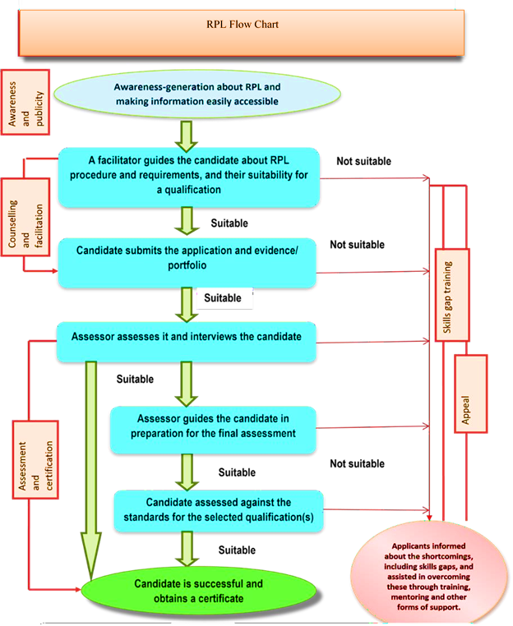

6. How do I know am eligible for RPL?

If you have solid experience and knowledge in your field of work acquired outside informal and non- formal learning setups, then you are eligible to attain a related qualification via RPL. RPL will recognise your experience and overseas qualification with a nationally recognised qualification and fill in any skills gaps you have with RTO’s 8training programs.
7. Who requires RPL?
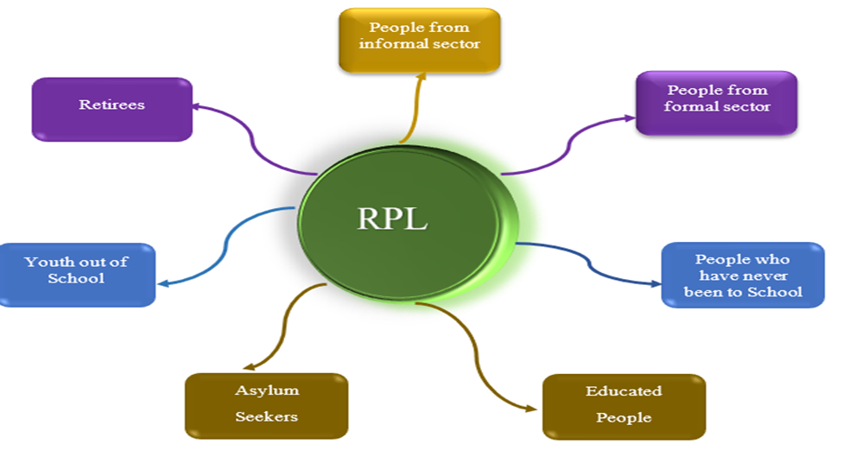

8. What does RPL involve?
There are three main areas that are considered during an RPL process:
- Existing work experience: The practical work experience you have gained to date may have provided you with solid skills and knowledge that are of relevance to a course of study. Work experience may be informal, formal, full time, part time, voluntary or paid.
- Existing qualifications: You may have completed educational courses that have provided you with knowledge and understanding that is of relevance to the course of study. For example, if you have another course or unit, this may count as credit toward a different qualification.
- Life skills and experience: Your general life experiences and the skills you have developed over time may also count toward the qualification you wish to complete.

9. Portfolio or Evidence Collection Assessment
What is a portfolio?
A portfolio is a detailed document developed by the student which identifies the learning acquired, through work and life experience, which may be equivalent to the learning outcomes in a College course(s). The portfolio describes the learning achieved from prior experience, relates the learning toward specific course/program requirements and verifies the learning through documentation or proof of learning. The student may be required to provide additional proof of learning and/or participate in an interview as part of the portfolio assessment process.
NOTE: For some courses, students may be required to prove prior learning through an Evidence Collection. This is a compilation of specific documentation identified by faculty as required to prove prior learning for the course(s learning outcomes.
Where can a student get assistance to develop a portfolio?
- The RPL Advisor assists with the portfolio development process and can provide the Portfolio Development Resource Guide.
- Program faculty in specific College programs may provide advice and or clarification.
- Students may complete a specific Portfolio Development workshop/course.
- Students should contact the RPL Advisor for assistance with the portfolio development process and to use the Portfolio Development Resource Guide.
What fees are associated with portfolios?
A fee is charged for each course portfolio submitted for assessment. A student must be enrolled in a RTP program/course, complete the Portfolio Assessment form and pay the application fee. Please see the institution website for the RPL Fee Range Guidelines.
Who assesses the portfolio(s) and/or evidence collection(s)?
Portfolios or evidence collections are assessed by RPL Assessor. This is usually an instructor who has subject matter expertise and has recent experience teaching the course. All Assessors who assess portfolios have access to RPL information, advice, and guidance in portfolio assessment through the RPL Services office. The assessors complete the Portfolio Assessment form and share results of the assessment with the student. The form is signed by the RPL Coordinator and recorded in the student information system.

What are the sample evidence required for assessment?

- Candidate’s C.V. outlining specific job positions and how they relate to specific skills requirements;
- Letters of recommendation where applicable;
- Sample(s) of candidate's work and products;
- Videos and/or photographs of work activities;
- Skills logbooks;
- Details of formal training, records of seminars, conferences and workshops attended, resume and performance appraisals;
- Testimonials from current or previous employers and customers;
- Completed performance reviews;
- Interview/professional conversation;
- Job descriptions.
10. How long does it take to complete the process?

The RPL process is typically a 6-week process from the point you submit your evidence portfolio.

11. What is the cost of RPL?

The cost of RPL is based on the needs of the Candidate and the number of units of competency for which they are seeking recognition. As such, the cost will vary from application to application. The Qualification Awarding Institutions (QAIs) in conjunction with stakeholders shall develop a differentiated Unit cost of Assessment to inform the total cost payable for an RPL application and advise the candidate before proceeding with the RPL assessment process. The fees chargeable will ensure sustainability of the RPL process and shall cover charges for KNQA, QAIs, Regulators and Assessment Centres.
12. How will RPL credit appear on a transcript?
Course credits achieved through an RPL assessment are recorded in the student’s academic record and an official QAI transcript may be issued. The College records successful RPL course assessment in the student information system in the same way in which grades are normally transcribed. Where this is not appropriate, the designation CR (Credit) is used. Unsuccessful RPL process will be recorded as Not Complete (NC) in the student information system.
The RPL Coordinator complete the Portfolio Assessment form and notify the student of either successful or unsuccessful RPL.
13. Can I appeal against a decision made by the assessment panel?
Yes, candidates have a right of appeal against the RPL. Assessment process is done and concluded within three months from the date of receipt by QAIs or authorized agent of QAIs.

14. What are the roles RPL Practitioners?
The effective implementation of the RPL process shall be performed by different persons, organizations and institutions. Each of them will perform their roles in accordance with the guidelines stated here below:

a). Kenya National Qualifications Authority (KNQA)
- Development and management of the national qualification framework;
- Establishing and managing the National RPL Coordinating Committee;
- Coordination and supervision of implementation of RPL Policies;
- Accreditation of QAIs wishing to assess RPL in the country;
- Registration of Qualifications in which RPL will be assessed;
- Accreditation of Regulations and Professional Bodies;
- Credit transfers and exemptions;
- Develop a system for assessment of national qualifications;
- Set standards &benchmarks for assessing RPL competencies, skills, knowledge, attitudes & values;
- Provide for the recognition of attainment of competencies through RPL including skills, knowledge, attitudes and values;
- Establish standards for the recognition of competencies obtained;
- Conducting training through RPL; and creating awareness to promote RPL to stakeholders.

b). Qualification Awarding Institutions (QAI)
- Accrediting assessment centres, facilitators, assessors and verifiers/moderators;
- Conducting training on RPL assessment for candidates, assessors and verifiers;
- Sourcing, adapting or developing and reviewing suitable assessment tools to be used for RPL;
- Organizing validation of the assessment tools;
- Developing, reviewing and disseminating guidelines for preparation of assessment process and preparing the materials in liaison with other stakeholders;
- Providing guidelines for RPL assessment, developing assessment examinations, monitoring assessment, recording learner’s achievements and issuing certification for the same;
- Coordinating RPL assessment process;
- Continuously updating assessment data bank of trainees;
- Awarding of certificates of competency to successful candidates in conjunction with training providers/ assessment centres;
- Accrediting themselves with the KNQA and ensuring that all RPL Qualifications being awarded are registered in the KNQF;
- Registering all RPL Qualifications awarded into KNQF.

c). Industry
- Developing Occupational Standards through Sector Skills Advisory Committees (SSACs)
- Participation in Policy formation for the RPL process and system;
- Providing expert workers to participate in curriculum development and assessment process;
- Contributing in the development and acquisition of training materials;
- Participating in external assessment of applicants;
- Providing opportunities for industry training and experience;
- Participating in verification of assessment of applicants.

d). Education Training Institutions and Skill Providers
- Establishing RPL management committee at college level and providing training needs to applicants;
- Providing competent RPL staff (accredited assessors & verifiers);
- Providing the necessary RPL tools, equipment and materials needed for RPL assessment;
- Management of RPL Candidates’ records;
- Ensuring Assessment guidelines are applied and maintained in the assessment centers;
- Registering with assessment bodies accredited by KNQA to carry out RPL assessment;
- Integrating RPL Policy into existing institutional Frameworks;
- Implementing the RPL review framework and providing feedbacks for applicants;
- Training and mentoring RPL applicants to ensure that they are ready for assessment as provided for by the TVETA Guidelines.

e). Trainer
These shall be professionals identified for:
- Conducting assessments, judging the evidence, making assessment decisions and preparing a report;
- Guiding and counselling the RPL Candidates accordingly;
- Delivering the unit(s) of competency using various strategies;
- Agreeing on the assessment plan with the candidate and fully briefing the candidate on the assessment process;
- Storage of candidate’s evidence.

f). RPL Candidate/Applicant
These are persons who shall register for RPL. They shall:
- Discuss and agree on assessment plan with assessors;
- Produce sufficient evidence of current competencies and of prior achievements (where applicable);
- Prepare their profiles and portfolio to meet the regulators of the RPL process;
- Prepare and avail himself/herself for assessment;
- Adhere to assessment rules and regulations;
- Follow appeals procedure when necessary;
- Be entitled to fundamental rights such as;
- The right to fair and transparent processes;
- Have a clear understanding of the learning outcomes to be met, assessment standards and criteria and the accreditation processes;
- Access to competent, trained and friendly educators and assessors;
- The right to be assessed by assessment methods which are flexible, appropriate to the subject and tailored to the needs of the candidate;
- The right to have prior learning evaluated and assessed for academic credits towards credentials within a reasonable period of time;
- The right to transfer credits gained by means of the RPL process; and
- The right to appeal a decision.

g). RPL Centre Managers
These are professionals appointed to be in charge of RPL assessment centers. They shall prepare candidates for assessment and upgrading of skills. Center managers shall;
- Provide adequate equipment and tools for RPL assessment;
- Pre- test the equipment and tools for assessment;
- Provide appropriate mediation tools for up skilling; and
- Provide security for assessment materials if any.

h). RPL Assessors
The RPL assessors shall;
- Develop appropriate tools and methods for each area of competency;
- Pre-test each assessment tool to ensure it is valid, reliable and consistent;
- Administer the assessment tool within the time and resources available;
- Assess one or group of learners;
- Organize for external assessment;
- Award and grade the achievement of each candidate in accordance with the following system; Grade A: 91 – 100 percent, Grade B: 81 – 90% and Grade C: 75 – 80%. The pass mark shall be 75% of marks in the final assessment;

Administer skills upgrading.

i). RPL Moderators
Moderators appointed by KNQA shall be responsible for moderation of assessment process and results.
The moderators shall:
- Sample not less than 5% of the candidates declared successful by an assessor;
- Use the sample to carry out rapid assessment by a different assessor;
- Analyze the overall percentages awarded by various assessors;
- In the event of significant variation, the moderator shall investigate and make a suitable recommendation to the Director General;
- Generate a report on moderation process;
- Submit the report to the assessing institution and Qualification Awarding institution.

j). RPL Coordinators
The RPL coordinators shall be appointees of QAIs; and shall;
  - Chair meetings of the RPL process team;
  - Consider the recommendations of the assessor and moderator on acceptance or rejection of the application;
  - Review and validate elements of the portfolios against set criteria and recommendations for the acceptance or rejection of the application;
  - Identify the unit standards used and to be used for the RPL process;
  - Evaluate the scope of RPL process;
  - Carry out the verification and Certification process;
  - Draw up a list of candidates to be assessed for each competency in the qualification for which the prior learning is sought;
  - Identify assessment centers with relevant facilities and resources for each candidate;
  - Set a date for assessment of each candidate at each center in accordance with set standards and guidelines;
  - Appoint assessors and moderators from QAIs or relevant professionals where applicable to carry out assessment and moderation;
  - Advise the assessing institution of any major issues arising from the RPL process requiring resolution;
  - Monitor and evaluate the RPL activities and advise QAIs on any matter or issue pertaining to the RPL system.

k). Regulators and Recognized Professional Bodies
For registration, accreditation and quality assurance of RPL centers, public regulators, professional bodies and competent bodies shall:
  - Develop standards and guidelines on RPL training and mentoring for their respective sectors, taking into account the RPL Policy developed by KNQA;
  - Monitor and evaluate the implementation of RPL within the specific sector they oversee, including the development and implementation of standardized approaches where appropriate;
  - Collaborate with KNQA and other stakeholders in Education and Training and other actors to advance the development of RPL;
  - Foster close working relationships with professional bodies in and across the sector where appropriate, to facilitate RPL;
  - Facilitate and monitor enabling agreements to increase RPL provisioning in their sectors;
  - Support and monitor the training of RPL advisors, facilitators, assessors, moderators, and administrators in their sectors;
  - Monitor providers that offer RPL in their sectors, in accordance with criteria established for this purpose;
  - Ensure consistency in the application of RPL policies by providers and delegated bodies in their sectors (where relevant);
  - Support the coordinated development of generic RPL toolkits and instruments relevant to the particular context for their sectors, wherever appropriate and possible;
  - Ensure quality and relevance of RPL qualifications awarded;
  - Develop and maintain an information management system that is compatible with the National Learners Records Database (NLRD) and other relevant government information management systems;
  - Conduct and oversee RPL-related research in the related sector in collaboration with KNQA and other stakeholders.

l). RPL Initiators (Pre-screeners)
These shall be appointed by accredited training institutions/ assessment centers;
The initiator shall:
- Validate the level of award of certificate for the possibility of credit transfer;
- Check whether the applicant’s portfolio is Complete and comprehensive;
- Mainstream special needs, disabilities or learning difficulties;
- Pre-evaluate the applicant’s portfolio and make recommendations to the QAI for the acceptance or rejection of the application.

m). Employers
For effective implementation of RPL, employers shall:
- Integrate RPL Policies into the existing employment laws;
- Sensitize and encourage employees to apply for RPL assessment;
- Identify employees’ skills for RPL application;
- Assist the employee to identify appropriate training and assessment opportunities
- Use the RPL qualification for recruitment and promotion;
- Use RPL for supervision and appraisal to employees; and
- Open opportunities for upskilling of specific skills.

15. Where can I get further information on RPL process and regulations?
RPL information and resources are available from the RPL Coordinator:
Kenya National Qualifications Authority KNQA Offices
Uchumi House, 6th floor
P. O. Box 72635 – 00200
Nairobi.
Email: rpl@knqa.go.ke / info@knqa.go.ke
Website: www.knqa.go.ke

